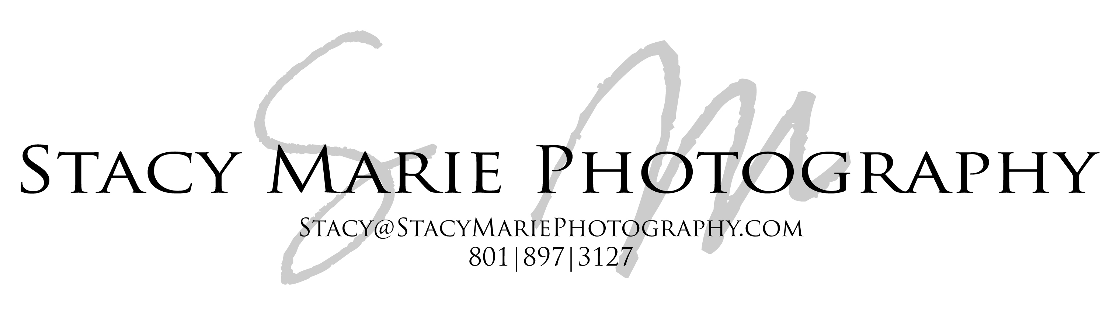

BIRTH SESSION CONTRACT

Client Name ________________________________________________ Today’s Date______________________________________

Phone Number___________________Address___________________________________________Email______________________

Due Date/Location of birth_______________________/____________________________________________________________
Induction Date & time (if applicable)______________________________/________________
It is understood that Stacy Nish of Stacy Marie Photography, is the exclusive official photographer retained to perform the photographic services requested in this contract on the day of the baby's birth.

Stacy Nish reserves the right to use the negatives and/or reproductions of the photos taken for display, publications, or other purposes. It is illegal to copy or reproduce these photographs elsewhere without photographer’s permission. The images are not licensed for commercial use or competition. The images are a finished work and are not to be altered in any way.

If Photographer cannot perform this Agreement in whole or in part due to any reason or cause beyond the control of the parties or due to Photographer's illness or injury, then Stacy Nish will return all fees to the Client(s) but shall have no further liability with respect to this Agreement. This limitation on liability shall also apply in the event that photographic materials are damaged in processing, lost through camera malfunction, lost in the mail, or otherwise lost or damaged without fault on the part of Photographer. It is also understood that Stacy Nish is not responsible for any injuries or damages that may be caused during the photo shoot.
Upon signing of this agreement by both parties hereto, Stacy Nish of Stacy Marie photography will reserve the time and date agreed upon and will not make another reservation for the specific time frame. For this reason, all deposits are non-refundable* due to client cancellation, even if the shoot becomes cancelled for any reason. In the event that something should happen during labor and/or birth beyond the control of Client or Photographer, that prevents Photographer from taking photos, the Client is still responsible for the full deposit and half of the service fee total.
The service fee is $___800.00_____. This includes 1 professional birth session and 1 professional newborn session plus all images from the sessions, fully edited, in high resolution digital format with a print release. A deposit of $__150.00_____is due at the signing of this agreement to secure your photo shoot date and time with a further payment of all necessary expenses (unless otherwise specified) including, but not limited to: parking, fuel, travel, entrance fees, etc. (when applicable), to be paid on or before the day of the shoot. The deposit is non refundable in case of cancellation by client*. If Client cancels within two weeks of photo shoot date, they are responsible to pay the full service fee amount. No photos or prints will be released and no rights are granted until timely payment is made in full. Late payment fees may apply.*If Client miscarries or the pregnancy has to be terminated, Client will be refunded half of the deposit amount and will not be liable for remaining service fees.
Please allow two-three weeks from photo shoot dates to receive photos. Photos can be rushed for an additional price.
I / we, the undersigned Contracting Party, hereby warrant that I am / we are competent to contract in my / our own name(s). I / we confirm that I / we have read the herein agreement prior to its execution and I / we are fully familiar with the contents thereof. This agreement shall be binding upon us and our heirs, legal representatives and assigns. And, we certify that we have received a complete copy of this agreement with all blank lines completed.
The terms of this agreement are accepted by:

Client ___________________________________________ Date _________________________

